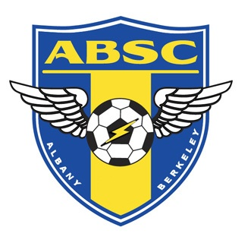

Sponsorship Commitment

Thank you for electing to sponsor the Albany-Berkeley Soccer Program this season. Please take a moment to review and select the sponsor package that best fits your business and budget.

Albany-Berkeley Soccer Club is a 501(c)(3) not-for-profit organization and will provide you with a letter stating that your donations are tax-deductible. Please select one of the sponsorship levels listed below.

- Primer Level ($5000)
- MSL Level ($2500)
- Regional Level ($1000)
- Club Level ($250)

Sponsor Name:_______________________________________
Business Name:_______________________________________
Address:_____________________________________________
City: _______________ State: _________Zip:______________
Phone: ______________ Email: _______________________
Signature:____________________ Date: _______________

Checks should be payable to Albany-Berkeley Soccer Club
Mailed to: 1442-A Walnut St #426 Berkeley, CA 94706

